**Mini Project Report on**



**TITLE**



**Submitted in partial fulfilment of the requirement for the award of the degree of**

**BACHELOR OF TECHNOLOGY**

**IN**

**COMPUTER SCIENCE & ENGINEERING**

**Submitted by:**

**Student Name.** **University Roll No.**

***Under the Mentorship of***

**CANDIDATE’S DECLARATION**

I hereby certify that the work which is being presented in the project report entitled **“Online Travelling System”** in partial fulfillment of the requirements for the award of the Degree of Bachelor of Technology in Computer Science and Engineeringof shall be carried out by the under the mentorship of Department of Computer Science and Engineering.

Name University Roll no

**Table of Contents**

|  |  |  |
| --- | --- | --- |
| **Chapter No.** | **Description** | **Page No.** |
| Chapter 1 | Introduction | **4** |
| Chapter 2 | Literature Survey | **6** |
| Chapter 3 | Methodology | **8** |
| Chapter 4 | Result and Discussion | **10** |
| Chapter 5 | Conclusion and Future Work | **12** |
|  | References |  |

**Chapter 1**

**Introduction**

* 1. **Introduction**

The main purpose of Online Travelling is provide a best facility and travelling services for a customer to book train, bus and cab for trip purpose. We have developed online travelling system in C++ language to provide a same services according to their choices.

This platform provide easy way to book tickets for train and bus without any difficulty and provide cab booking at reasonable price.

We create this system to establish and expand the structure of tourism that provides healthy interaction opportunities for tourists and natives and improves a Better awareness of different cultures, traditional lifestyles, traditional knowledge and moralities. This system moreover provides a better way to connect with various events.



**1.2 Background**

For many years, reservation was an off-putting, difficult task. With the growing number of customers, carriers had to overcome numerous challenges to make booking fast, convenient, and operationally easy. Twenty years or so down the road in the 60s, the whole booking process could be accomplished in minutes – through a travel agent. Fast forward to today – and previously unimaginable – travelers enjoy fully automated ticket booking, reserving and paying for tickets using smartphones.

**1.3 Key Application**

A travel management system (TMS) is associated with corporate travel management, but it can also be used by non-corporate organizations. A TMS can provide you with reports on your booking activities and help you track your business growth in real-time. It not only helps in automating the processes but also makes them efficient.

**Chapter 2**

**Literature Survey**

**2.1 overview of Online Travel Industry**

An online travel industry consists of my companies that arranges and sells accommodations, tours, transportation and trips on an online platform for travelers. They are third parties who sell services on behalf of other companies.

**2.2 Technology**

Travel Technology means using technology for trip planning and automates travel process - bookings, inventory, payments, itineraries and back-office operations for travel agencies and tour operators to enable online bookings for customers and increase bookings and revenues.

Travel Technology plays an important role in travel and tourism industry. It is changing the way travel companies target travelers, offering all travel services - hotels, flights, tours, transfers and activities in online platform to plan their entire trip within minutes and improve visitor experience.

In Competitive Travel Industry; it’s very important for travel agents, travel agencies, tour operators, hotel operators and travel companies to keep up with the latest trends in travel technology to maintain their business in top position in travel industry.

**2.3 Features**

Every business is dependent on its user experience. As far as the travel industry is concerned,  if

a user faces any difficulties in booking their rides, accommodation, etc they will approach other TMS. To avoid losing business or customers, building a user-friendly booking tool is most important.

We can expect easy and upgraded  payment options other than cash from TMS while traveling like QR codes, UPI IDs, online banking, debit or credit cards.

**2.4 COVID 19 and its Impact on Online Travel**

The [COVID-19 pandemic](https://en.wikipedia.org/wiki/COVID-19_pandemic) has impacted the tourism industry due to [the resulting travel restrictions](https://en.wikipedia.org/wiki/Travel_restrictions_related_to_the_COVID-19_pandemic) as well as slump in demand among travelers. The tourism industry has been massively affected by the spread of [coronavirus](https://en.wikipedia.org/wiki/Coronavirus_disease_2019), as many countries have introduced travel restrictions in an attempt to contain its spread.[[1]](https://en.wikipedia.org/wiki/Impact_of_the_COVID-19_pandemic_on_tourism#cite_note-1) The [United Nations World Tourism Organization](https://en.wikipedia.org/wiki/United_Nations_World_Tourism_Organization) estimated that global international tourist arrivals could have decreased by 58% to 78% in 2020, leading to a potential loss of US $0.9–1.2 trillion in [international tourism](https://en.wikipedia.org/wiki/International_tourism) receipts.

**2.5 Future Trends and Challenges**

The online travel market is expected to continue to grow in the future. The growing popularity of mobile devices, and the growing demand for personalized travel experiences, are all expected to drive the growth of the market. As the market continues to grow, OTAs will need to continue to innovate and adapt in order to stay ahead of the competition. OTAs will need to offer new and innovative features, such as AI-powered personalization, in order to attract and retain customers.

**Chapter 3**

**Methodology**

The provided C++ code implements a Travelling System with functionalities for Train Booking, Bus Booking and Cab Booking.

**3.1 User Management**

**1- User Profile Structure:**

. It store user information such as username, password and emil id.

. Functions like ‘Adding_new_client,’login_client’,’WriteToFile’ and ‘InitializeListing’

manage user Profiles and handle user authentication.

**2-Login and Logout Mechanism:**

. User can log in and log out through the ‘login_client’ and ‘logout_client’ functions.

. The program keeps track of the current user’s state.

**3.2 Booking System**

**1- Train Booking:**

. User can install new trains, make reservations, check seat availability, and view train

details.

. Train data is stored in the ‘train_data.txt’ file.

**2- Bus Booking:** .User can install new trains, make reservations, check seat availability, and view bus

details.

. Train data is stored in the ‘train_data.txt’ file.

**3- Cab Booking:**

. User can book a cab by providing pickup and drop-off details, including distance.

. The cost calculation is based on the distance traveled.

. Booking details are displayed, and users can confirm or exit.

. Cab data is stored in the ‘cab_data.txt’ file.

**3.3 Main Menu and Navigation:**

**1-Main Menu:**

. The program begins with a main menu where users can add new profiles, log in and exit.

**2-Main Program Loop:**

. The program runs in loops, allowing users to navigate between different functionalities.

**3-File Handling:**

. User profiles, train data, bus data and cab data are stored in text

files(‘users.txt’,‘train_data.txt’, ‘bus_data.txt’, ‘cab_data.txt’).

. File I/O functions(‘WriteToFile’, ‘loadFromFile’) handle reading from and writing to these

files.

**Chapter 4**

**Result and Discussion**

-This Screen will be shown when you run the code first time.



-After Successfully Login this screen will be shown.

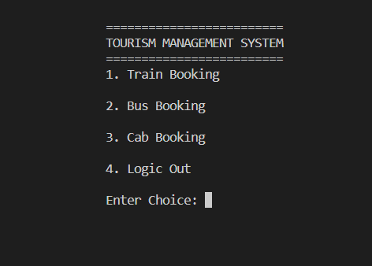

-If you select the option 1 then this screen will shown.

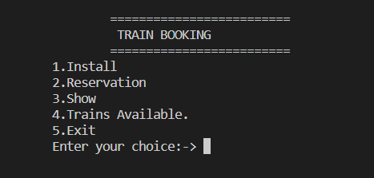

-If you select the option 2 then this screen will shown.

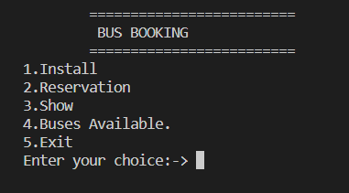

-If you select the option 3 then this screen will shown.

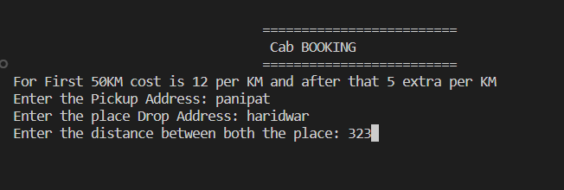

-If you select the option 4 then you will return to the login screen.

**Chapter 5**

**Conclusion and Future Work**

**1-Conclusion**

In the conclusion, the implementation of the online traveling system has proven to be significant milestone in streamlining booking operations and enhancing customer experiences. The comprehensive Testing and evaluation phases have validated the system’s functionalities, security measures, and compliance with regulatory standards.

**2-Future Work**

The current version of the online traveling system is simple and includes only the feature of booking tickets. In the future, we can enhance the code by introducing new features such as hotel booking, flight booking and many more, based on user demand.

**References**

[1] https://en.wikipedia.org/wiki/Travel_technology

[2] <https://codetheorem.co/blogs/must-have-features-for-travel-website>